EX.NO: 01

DATE:13.10.2020

AIM:

To print the calendar of given month and year else print message “Invalid Input”.

**PROGRAM:**

import calendar

year = int(input("Enter Year: "))

month = int(input("Enter Month: "))

if( year>1000 and year<9999) and (month>0 and month<13):

print(calendar.month(year, month))

else:

print ("Invalid Input")

**LINK:**

http://103.53.53.18/mod/vpl/forms/edit.php?id=229&userid=1721#vpl_file0

**OUT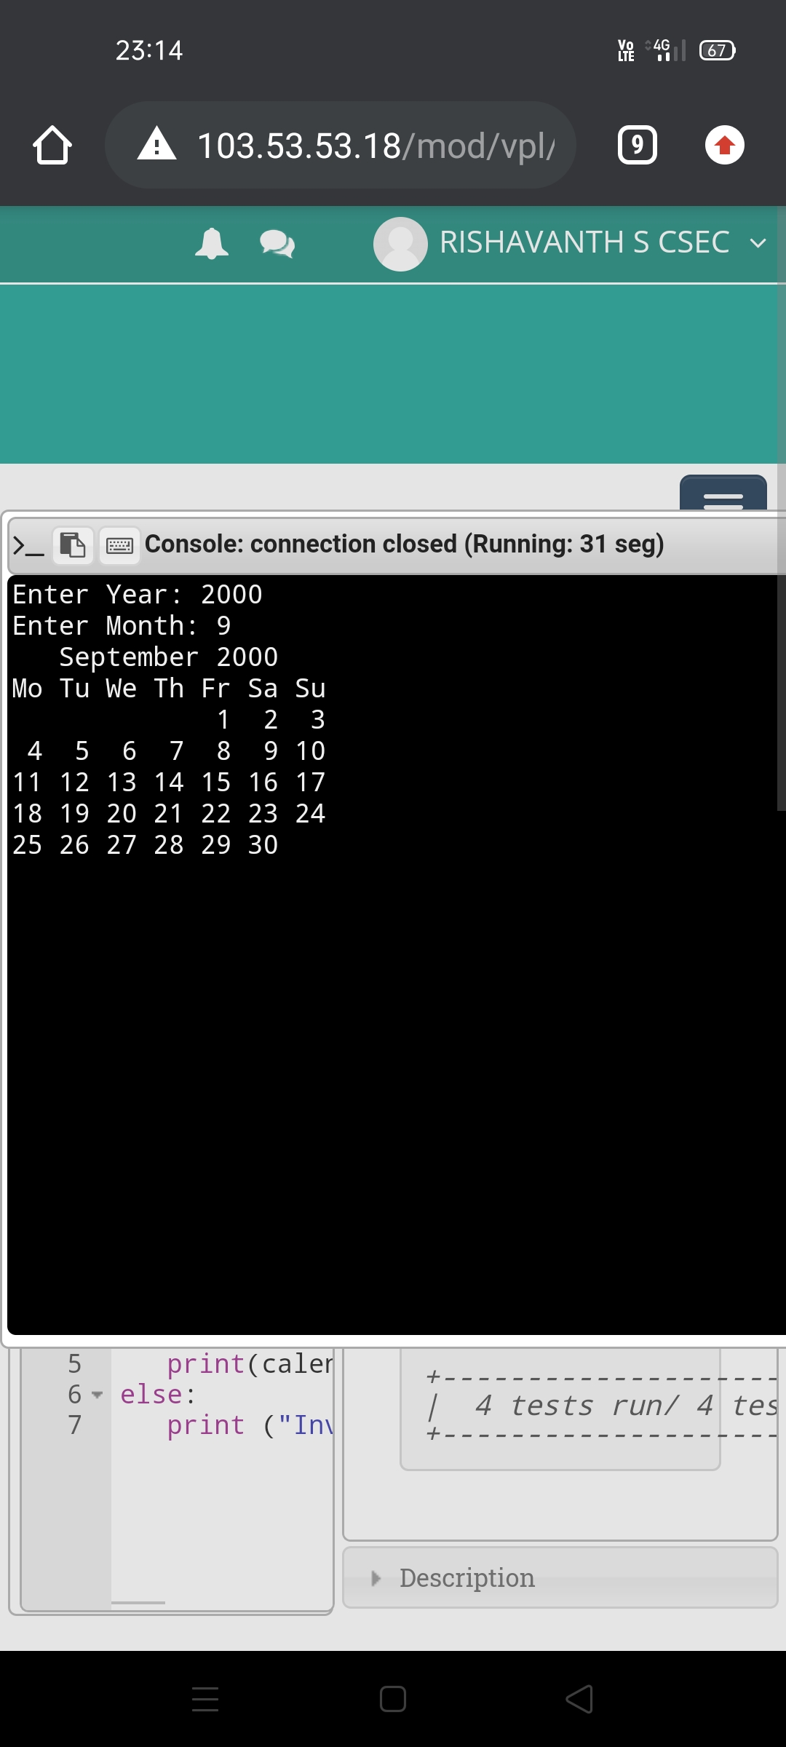PUT:**

**RESULT:**

The output of the program is successfully obtained.